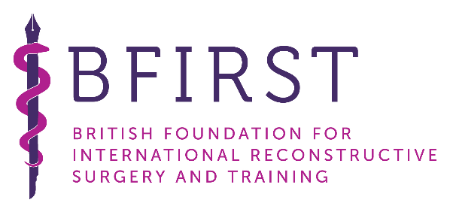
Overseas Fellowship

Application Form

Who is eligible to apply for the BFIRST Fellowship?
- Fully Trained Plastic Surgeons: Senior Registrar or Consultant
- Currently working within an established Plastic Surgery Unit in a developing country
- Please see fellowship webpage for list of priority countries

What should be included with your application?
- Complete this Application Form
- Curriculum Vitae
- Two Letters of Reference supporting your application

Who would be an appropriate Referee?
An appropriate referee should ideally be a Head of Department, Consultant colleague or Supervisor with whom you have worked as a plastic surgeon.

What should the letter of reference contain?
- Details of progress and achievements made by the applicant in plastic surgery to date
- How the fellowship would benefit the applicant
- How the applicant would implement change as a result of the fellowship in their unit

Where should completed applications be sent to?
- Please email a copy of your application to fellowship@bfirst.org.uk

The deadline for fellowship applications is 31st July each year

What will happen if my fellowship application is successful?
- BFIRST will contact you via email in September regarding the application result
- BFIRST will arrange a 6-week observational fellowship for you in a UK plastic surgery unit
- The fellowship should take place between 1st January and 31st September in the year following the fellowship application
- BFIRST will provide expenses for air travel, visas, accommodation and living costs during the fellowship
- You must provide evidence of comprehensive health insurance which covers your stay, before making travel arrangements to qualify for the Fellowship should you be accepted
- It is expected that successful applicants come to the UK alone, as regrettably BFIRST is unable to facilitate additional family members during the fellowship.
Full Name
Date of Birth
Gender
Surgical Position & Date Appointed
Hospital
City
Country
Home Address
Email
Do you have a contact in plastic surgery or a specific hospital you wish to visit in the UK?
Special areas of interest (eg: burns, hands, clefts, craniofacial, paediatric, head & neck, breast etc)
**application for aesthetic surgery will not be accepted**
When do you wish to start?
Have you previously been awarded a surgical fellowship? If so, please give details
Name of referee 1
Email
Name of referee 2
Email

Reason why you are applying for this fellowship (200 words maximum).
Please include:
- Why do you wish to visit the UK?
- Why do you wish to spend time in your chosen hospital?
- What do you expect to gain from your visit?
If you are awarded the fellowship, please describe the impact it would have in your country (200 words maximum).
Please include:
- How would it effect on your surgical service?
- Who, apart from yourself, would benefit if you are awarded the fellowship?
- How will you share your UK experiences when you return to your country?

